MODULE: ALGORITHMS AND PROBLEM-SOLVING USING PYTHON

TITLE:
IMPLEMENTATION AND ANALYSIS OF SORTING ALGORITHMS FOR LIBRARY BORROWING RECORDS USING PYTHON

NAME:
ID:
WORDS: 2157

Table of Contents
1. Introduction 3
2. Problem Analysis and Requirements 3
3. Data Structures and Data Types Selection 4
4. Sorting Algorithm Analysis 5
5. Algorithm Design and Flowchart Explanation 6
6. Python Implementation 8
7. Results and Testing 9
8. Conclusion 11
9. Future Improvements 11
10. References 13

1. Introduction
Algorithms constitute a key aspect of a computer science as they give structured guidelines to solve computational problems effectively. A good algorithm enhances the performance of software by minimising processing time, memory usage and unwarranted uses of software. In information systems nowadays, datasets become very large; hence, correct choice of algorithms is significant to organise and retrieve a data many times faster.
Data processing largely involves sorting algorithms since they help to organize data in an order of meaning. Organised data enhances the act of searching, reporting and decision-making. The performance characteristics of different sorting algorithms differ such that an algorithm that is efficient on a small set of data might not be efficient on a large number of records.
The current project aims at coming up with an algorithmic solution to library management system. The library has a record of borrowing loans which records the names of the borrowers and the number of days each borrowed item has been held by the borrower. These records should be grouped in increasing terms on borrowing duration in order to come up with an overdue report in the system (Wibowo and Faisal, 2024). The difficulty here will be in identifying an appropriate sorting algorithm that works effectively both on small daily records, as well as on large monthly data sets that have over 10,000 entries.
This project is designed to study various sorting algorithms, their time and space complexity and provide a practical solution on using Python as an efficient sorting algorithm (Das, 2025). The program created reads in data about borrowing operations in a text file, uses sorting algorithms and finds those that are overdue using these algorithms, and executes performance measurement of the whole program by comparison, swap, arithmetic operations and processing time.

2. Problem Analysis and Requirements
The library situation at hand would entail the handling of the information about borrowers stored in a plain text file. The borrowers name and the number of days that the library item has been in possession are two crucial pieces of information that are contained in each record. The generation of overdue reports without automated sorting approach makes it inefficient particularly whereby the size of the dataset is limited to a few transactions daily to thousands of daily records monthly.
The primary need of the system is to sort the records of borrowers in order of their numbers by the number of days. To illustrate, Emma shall be reclassified to have 23 days, Liam shall have 5 days and Sophia shall have 31 days so that the borrowers with less days should be place first.
The input data have two fields. The name of the borrower is done as a string value with the period of borrowing as an integer value. This is read in the developed Python program, which reads the library records in the library records.txt file and places it into a format that is then amenable to processing.
The desired results are: orderly list of borrowers, the name of defaulter users, the number of records processed, the execution time, and the total number of computational procedures. The borrowing system will consider a borrower as defaulting when the period taken to borrow money goes beyond the stipulated 14 days. Information on the performance such as comparison, swaps and arithmetic operations are also displayed to examine the efficiency in an algorithm.

3. Data Structures and Data Types Selection
Proper data structure is also significant as it has a direct impact on efficiency and performance of programs. The system implemented works with various data types and structures in Python to arrange the information of library borrowing in an efficient manner.
Borrower name is also saved in the form of string data type since they comprise names. The borrowing days are saved as an integer as it should be possible to sort using the operations of a numerical comparison (Lafore, Broder and Canning, 2022).
A list of dictionaries is the main data structure that will be used in this project. For example:
records = [
{"name":"Emma", "days":23},
{"name":"Liam", "days":5}
]
The reason a list is best is that it has a dynamic storage method, indexing and effective iteration in the sorting process. Records can be easily accessed and compared using lists, such as the Merge Sort, Bubble Sort, Insertion Sort and Quick Sort algorithms. The reason why dictionaries are used is that it is clear on which borrower name is associated with the corresponding time of borrowing.
Other data structures had also been taken into consideration. A stack is based on a Last-In-First-Out (LIFO) format and it is applicable in tasks that are related to reverse processing. But it cannot be used to sort records in a library since borrower data is not in need of LIFO behaviour.
A queue is based on the First-In-First-Out (FIFO) approach and would be useful in dealing with library request management systems. But queues are not beneficial in terms of organizing the borrowing records in terms of the period.
Trees, e.g., Binary Search Trees, are capable of sustaining ordered information and offer quicker searching actions (Fatima, 2023). Nevertheless, the adoption of a tree structure would add complexity to use with this scenario where the most important task is to sort out the existing records.
Graphs describe connections among the related objects and are applied to network related problems. The records of the library borrowing do not form an edge case and therefore do not require the usage of graphs to represent them.

4. Sorting Algorithm Analysis
Various sorting algorithms were evaluated to establish the best way to use the algorithm in the library management system. The analysis took into account the best-case, average-case and worst-case complexity since the system must be able to operate with small and large datasets.
Algorithm | Best Case | Average Case | Worst Case | Space
Bubble Sort | O(n) | O(n²) | O(n²) | O(1)
Insertion Sort | O(n) | O(n²) | O(n²) | O(1)
Merge Sort | O(n log n) | O(n log n) | O(n log n) | O(n)
Quick Sort | O(n log n) | O(n log n) | O(n²) | O(log n)
Table 1: Big-O Complexity Comparison of Sorting Algorithms
The bubble sort is based on the principle of repeatedly comparing neighbouring records and swapping them out in case they are out of order. It is easy to apply, but inefficient with large datasets due to large number of comparisons.
Insertion Sort is a procedure of sorting a list item by item. It is fast with well-sorted records but is slow with large random data due to its O(n²) worst-case complexity.
Quick Sort is a method of divide-and-conquer algorithm, in which a pivot value is chosen, and records around that pivot are partitioned. The results obtained in the test revealed that Quick Sort had a good execution speed. However, its worst-case complexity can lead to O(n²) performance, creating less predictable performance (Shabbir et al., 2023).
Merge Sort is also a divide-and-conquer algorithm. It separates records into pieces, sorts these pieces recursively and reassembles them. The performance of Merge Sort, in the best case, average, and worst case, is O(n log n) unlike Quick Sort.
Bubble Sort and insertion sort can still work successfully with small datasets since the number of records is limited. However, when 10,000 records were tested, these algorithms needed millions of operations. Thus, Merge Sort was chosen as the best algorithm since it offers a consistent and predictable performance with large library exports.

5. Algorithm Design and Flowchart Explanation
The algorithm design explains the entire series of operations of the library sorting system. The system starts with the reading of borrowing information presented in the text file or creating test datasets. The data is checked to make sure that you store the name of the borrower as a string, and the days when he/she borrows as an integer.
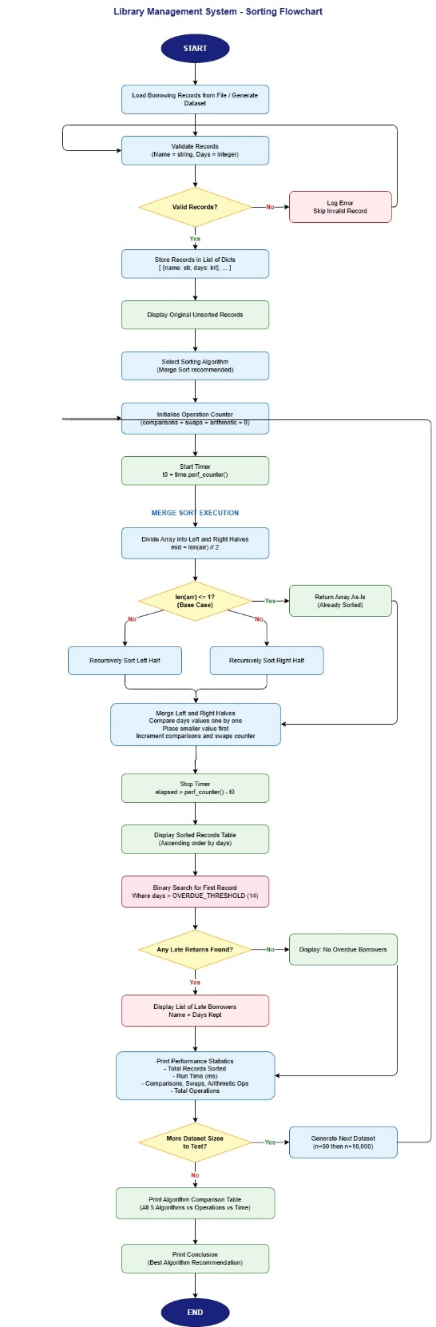
Figure 1: Library Management System Sorting Flowchart
Once the validation is done the records are stored within a list of dictionaries. The program next chooses the sorting algorithm and sets the operation counters to perform the comparisons, swaps and arithmetic operations.
The initial phase of Merge Sort is to separate the data into the left and right parts till the base condition is achieved. The smaller parts are then sorted and amalgamated again through a comparison of the borrowing days. Computational operations are captured in the program in the process.
Once the sort has been completed, the execution timer is halted and results are shown in increasing order of the system (Skorpil and Oujezsky, 2022). The program then decides the borrowers who passed the overdue limit of 14 days and makes the final report of records in order, with performance statistics.

6. Python Implementation
Python programming language was used to develop the solution in place of other programming languages due to its good support of algorithms, data structures and object-oriented programming. Implementation consists of functions, modules and libraries as well as classes.
A number of Python libraries were utilized in the program. Time module The time execution time of an algorithm is measured through time.perf counter (Reya et al., 2023). The testing datasets are created by the random and the string modules and deepcopy avoids make alterations on the original dataset in cases where they are required to be compared in terms of sorting.
This program consists of various functions such as bubble_sort, insertion sort, merge sort and quick sort. Functions have a variety of different sorting algorithms, where one can compare performances.
Another class by the name of OpCounter was developed to monitor operations of calculations. The number of comparisons, swaps and arithmetic operations done in sorting is stored in this class. This helps in the analysis of the performance in details rather than just by measuring the execution time.
This program manages to read data in library records.txt file, sort the records of the borrowers and print the results and identify those who are close to deadline (Abuba et al., 2025). The find late returns () function is used to validate records in which there are more than the amount due similarities in the number of days.
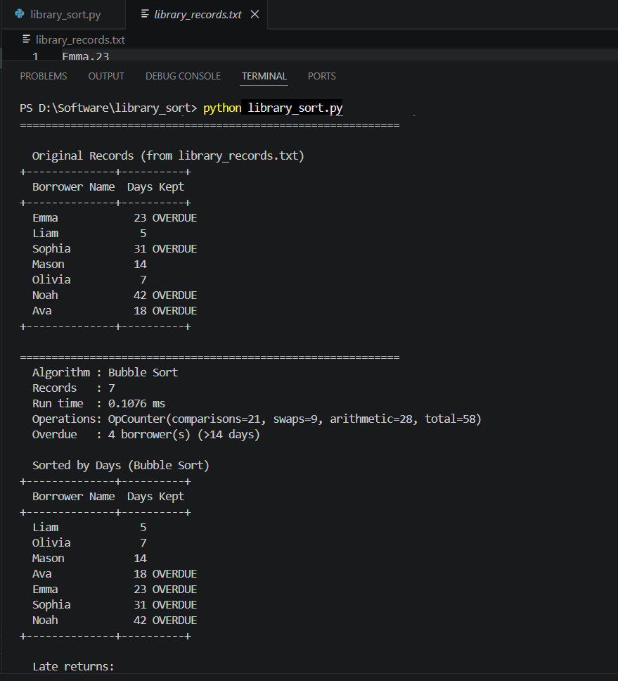
Figure 2: Python Program Execution Showing Sorted Borrower Records
The ultimate implementation meets the system requirements by showing the number of records processed in total, running time, the outcome of the sorting and results of the computational complexity.

7. Results and Testing
The testing was done with a small dataset, medium dataset and large dataset. The sample of the data set consisted of seven records in the assignment sample.
Before sorting:
Emma – 23 days
Liam – 5 days
Sophia – 31 days
After applying Merge Sort:
Liam – 5 days
Olivia – 7 days
Mason – 14 days
Outstanding borrowers, such as Ava, Emma, Sophia and Noah, were tracked down successfully.
Algorithm | Comparisons | Swaps | Arithmetic Operations | Total Operations | Runtime (ms)
Bubble Sort | 21 | 9 | 28 | 58 | 0.1076
Insertion Sort | 17 | 15 | 26 | 58 | 0.1021
Merge Sort | 16 | 20 | 78 | 114 | 0.0811
Quick Sort | 20 | 13 | 19 | 52 | 0.0708
Table 2: Small Dataset Performance Results
Merge Sort took a time of 0.0811 milliseconds with 114 total operations working with the small dataset.
A medium amount of 50 records that were generated were also tested.
Sorting Algorithm | Comparisons | Swaps | Total Operations | Runtime (ms)
Bubble Sort | 1,176 | 583 | 2,978 | 3.4458
Insertion Sort | 638 | 632 | 1,961 | 1.2599
Merge Sort | 229 | 286 | 1,592 | 0.8968
Quick Sort | 300 | 101 | 663 | 0.6691
Table 3: Medium Dataset Performance Results
Merge Sort took about 0.8968 milliseconds, and had completed processing using 1,592 operations.
The test that was the most significant utilized 10,000 records.
Sorting Algorithm | Comparisons | Swaps | Arithmetic Operations | Total Operations | Runtime (ms)
Bubble Sort | 49,978,724 | 24,667,427 | 49,988,550 | 124,634,701 | 32193.46
Insertion Sort | 24,677,439 | 24,677,426 | 24,687,445 | 74,042,310 | 14342.54
Merge Sort | 119,971 | 133,616 | 517,166 | 770,753 | 126.50
Quick Sort | 132,000 | 43,996 | 122,940 | 298,936 | 117.39
Table 4: Large Dataset Performance Results
Bubble sort took 124,634,701 operations and an average of 32 193 milliseconds. It took Insertion Sort 74,042,310 operations (Sabah et al., 2023). Comparatively, however, Merge Sort took just 770,753 operations and only took around 126.50 milliseconds to execute.
The data obtained by these experiments show that Merge sort is much better to handle large volume of records within a library.

8. Conclusion
This project was able to create a Python based sorting algorithm of a library management system. Various sorting algorithms were realized and compared: Bubble Sort, Insertion Sort, Merge sort and Quick sort.
The results of the experiment indicated that simple algorithms are able to work with small datasets but do not perform well with thousands of records. Merge Sort was chosen as the most suitable solution since this algorithm has a steady O(n log n) complexity at all times.
The primary benefits of Merge Sort are that it is stable, predictable and can handle large datasets. but its disadvantage is that it requires more memory as temporary arrays have to be formed when merging.
The system developed was able to address the necessary goals of sorting records, identifying and evaluating overdue borrowers and analysing the performance of algorithms.

9. Future Improvements
The library sorting system could be enhanced by adding capabilities in the future. Through the use of a database like SQLite, that may substitute text files, storage and search facilities are enhanced. The system might be simplified by the use of a graphical user interface which might be easy to use by the employees of the library.
The system can also be enhanced with cloud storage functionality, auto email notifications of delays borrows and machine learning to forecast the borrowing behaviour. It can be optimised with more advanced optimisation techniques like parallel sorting that will be advantageous when dealing with very large datasets.

10. References
Abuba, N.S., Baagyere, E.Y., Nakpih, C.I. and Wiredu, J.K., 2025. Optiflexsort: a hybrid sorting algorithm for efficient large-scale data processing. Journal of Advances in Mathematics and Computer Science, 40(2), pp.67-81.
Das, U., 2025, June. Python or Java in a Data Structures course? How about both?. In 2025 ASEE Annual Conference & Exposition.
Fatima, P., 2023. Optimizing Algorithm Efficiency through Advanced Data Structures in C++: A Comparative Analysis of Performance, Scalability, and Complexity. International Journal of Computations, Information and Manufacturing (IJCIM), 3(2), pp.66-72.
Lafore, R., Broder, A. and Canning, J., 2022. Data structures & algorithms in Python. Addison-Wesley Professional.
Reya, N.F., Ahmed, A., Zaman, T. and Islam, M.M., 2023. GreenPy: evaluating application-level energy efficiency in Python for green computing. Annals of Emerging Technologies in Computing (AETiC), 7(3), pp.92-110.
Sabah, A.S., Abu-Naser, S.S., Helles, Y.E., Abdallatif, R.F., Samra, F.Y.A., Taha, A.H.A., Massa, N.M. and Hamouda, A.A., 2023. Comparative analysis of the performance of popular sorting algorithms on datasets of different sizes and characteristics.
Shabbir, A., Majeed, A., Iftikhar, M., Ali, R.H., Arshad, U., Shabbir, M.Z., Ijaz, A.Z., Ali, N. and Aftab, A., 2023, October. A review of algorithms’s complexities on different valued sorted and unsorted data. In 2023 International Conference on IT and Industrial Technologies (ICIT) (pp. 1-6). IEEE.
Skorpil, V. and Oujezsky, V., 2022. Parallel genetic algorithms’ implementation using a scalable concurrent operation in python. Sensors, 22(6), p.2389.
Wibowo, F.R. and Faisal, M., 2024. Comparative analysis of sorting algorithms: TimSort Python and classical sorting methods. JISA (Jurnal Informatika dan Sains), 7(1), pp.11-18.

